# Visualize Your Index Constituent Correlations

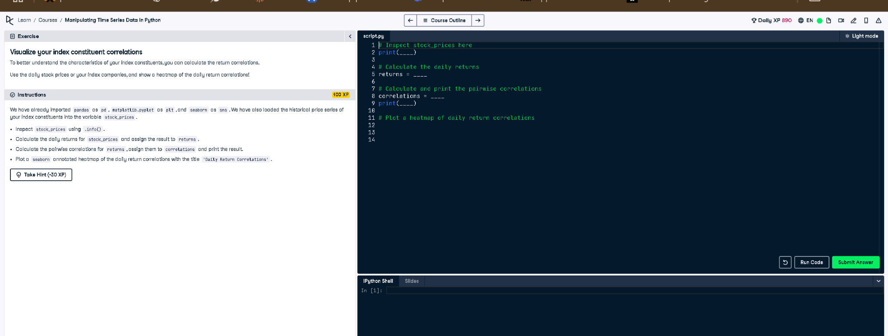

## ✅ Full Correct Answer:

# Inspect stock_prices here  
print(stock_prices.info())  
  
# Calculate the daily returns  
returns = stock_prices.pct_change()  
  
# Calculate and print the pairwise correlations  
correlations = returns.corr()  
print(correlations)  
  
# Plot a heatmap of daily return correlations  
import seaborn as sns  
import matplotlib.pyplot as plt  
  
sns.heatmap(correlations, annot=True, cmap='coolwarm')  
plt.title('Daily Return Correlations')  
plt.show()

## 🧾 Explanation (Simple Words):

You start by inspecting the stock price data. Then, you calculate daily percentage returns for each stock. After that, you compute the correlation between all these return series. Finally, you visualize the correlations in a heatmap using Seaborn, which makes it easy to see how stocks move together.